

WORKING PAPER
Practical Modelling of full profile eCooking Loads

Date: July 2026
Organisation: Gamos
Authors: Tim Woolnough, Nigel Scott, Matt Leach

This material has been funded by UKAid from the UK government; however the views expressed do not necessarily reflect the UK government’s official policies.

Contents
Introduction 3
Preamble 4
Background 4
Data Sources 4
Methodology & Discussion 5
Gaussian Curve Fitting 5
Cooking diaries 9
Mealtime Peak LoaD Factors 9
Note on diversification factors 10
Applying Peak Load Factors 11
Utilising Methodology Example 11
Data quality 11
Estimating Maximum Possible Load 12
Minimum inputs 12
Reflection on consistency 15
Limitations 16
Conclusion 17

Introduction
Understanding the expected grid load profile associated with cooking using electricity is crucial for building a case for the adoption of electric cooking. When households who currently perform their cooking using traditional methods (often cooking by burning biomass fuels) transition onto electric cooking, electricity suppliers will experience an increase in demand. This increase provides the supplier an opportunity for market expansion, but such an expansion must be carefully planned for to ensure reliable and safe supply – safe for both the user and the supporting infrastructure.
MECS’ recent working paper titled “Diversification Effects for Practical Modelling of Cooking Demand” introduces the role of diversification factors when estimating the required capacity increase for electricity infrastructure. While this metric is widely used in power systems planning and design, its usefulness is limited by its single dimension – the load is simply estimated from the total possible demand and the maximum observed demand. This means that the diversification factor does not take into account the time of day at which the peak demand occurs.
While the diversification factor is therefore a sensibly conservative figure, we might expect to commonly encounter a scenario where an existing grid has a load profile with a peak not aligned to the additional load profile generated from cooking transitions to electricity. This would mean that the new combined load profile (built from the sum of the existing and cooking profiles) will see a peak load lower than the peak load predicted by simply adding the diversified eCooking load to the existing peak. When eCooking load occurs outside of the periods in which the grid is stressed, then the additional demand actually creates value with minimal impact on the grid infrastructure. As such, it is important to be able to estimate full 24-hour load profiles to understand the benefits of increasing load outside of the time of existing peak load.
Our objective here is to propose a methodology which can be used to easily provide energy planners a more nuanced understanding of the likely impact of cooking transitions on their existing load profiles, aiming to generate estimates of full profiles for cooking transitions using data gathered from a baseline phase – i.e. enabling planners to estimate the impacts of electric cooking additions to a grid in advance of those electric cooking additions being made. The proposed methodology can be performed using a small number of easily measurable / estimated input variables. This methodology is a refined version of the approach first employed within TIMeC – a tool developed for rapid exploration of how changes to cooking practices will affect cooking costs, time, and the demand on the grid, amongst other outputs.
This paper discusses the validation process for the proposed load profile estimation approach using curve fitting alongside existing detailed data from implemented electric cooking projects, showcasing suitability for a range of countries, and introducing peak load factors in the context of estimating load profiles from mealtimes. The paper also investigates how the outlined methodology can be used with only data gathered before the introduction of electric cooking to estimate the load profile when electric cooking is introduced using a case study.
The methodology described within this paper can be quickly replicated using the tool provided on the MECS website titled “Household eCooking Load Profile Generator”.

Preamble

Background
The Implications Model for eCooking (TIMeC) proposed the idea that cooking loads can be modelled as a summed series of gaussian load profiles, hypothesising that cooking load at each of the three main mealtimes (breakfast, lunch, and dinner) can be sufficiently well represented using simple normal curves centred at the average cooking times. The sum of these curves will then represent the full load profile from cooking over a full day.
With access to a rich Internet of Things (IoT) data source from implemented cooking projects, it has become possible to investigate whether the following hypothesis holds true:
“Cooking load profiles can be well approximated by the sum of three normal curves representing cooking at breakfast, lunch, and dinner.”
Within this paper we first show that load profiles can be represented to a good level of accuracy using a summed series of normal curves. We then explore how those normal curves can be calculated and provide some initial library parameters extracted from real cooking load profiles from three countries. Finally we explore how a load profile can be estimated from data gathered about non-electric cooking habits using a case study example.

Data Sources
This paper makes reference to TIMeC, a MECS owned tool used for exploring the outcomes of cooking transitions, where the methodology developed within this paper was first explored.
The data used to validate the proposed curve-based representation of load profiles is the same data used within the previous MECS working paper “Diversification Effects for Practical Modelling of Cooking Demand”, which introduces diversification factors. The data was collected by BURN and includes IoT information on cooking events, importantly including when cooking took place, the duration of cooking, and the energy consumption. The data used for this analysis was gathered over 3 months, between Jan 2nd and March 31st, 2025, and includes reports from an average of around 3,000 unique devices per day. This IoT data is gathered through automatic reports on BURN stove usage.
For the investigation on whether the proposed estimation methodology is suitable for cases where no data on actual electric cooking load is yet available (i.e. for cases where the interest is in estimating the expected load), household survey data is used. The selected household survey data is gathered from a number of households who report all cooking related activities over a ‘baseline’ period to understand the existing cooking habits. The same group is then provided improved access to electric cooking, and reports data on all cooking activities over a ‘transition’ phase. We can use the baseline phase as inputs to our load estimation methodology to produce an expected load profile and compare this with the ‘real’ load profile built from the transition phase.

Methodology & Discussion

Gaussian Curve Fitting
The first step of this process was to investigate whether the real cooking load profiles observed from the BURN data can be represented by a summed series of gaussian curves. With this data we are in the enviable position of already having the full profiles. Therefore in this particular case we do not need to try to represent the profiles. However, for many projects, energy planners and modellers will not have this depth of data.
The BURN data reports on three countries:
- Kenya, N=1469 average number of devices in use per day
- Tanzania, N=1416 average number of devices in use per day
- Ghana, N=168 average number of devices in use per day
The combined data over a 3-month period between January 2025 and March 2025 were used to create daily grid load profiles for each day and each country. These load profiles were then averaged to create a single representative load profile for each country. A script was written to fit gaussian curves to the load profiles. Through experimentation, it was decided that some basic realistic constraints must be applied to the curve fitting, including:
- 3 meals (3x normal curves) must be represented
- Minimum separation between meal means must be 180 min or greater
- The standard deviation (per meal) is limited to a maximum of 120 minutes
During the curve fitting process we discovered that if the standard deviation per meal was not limited, occasionally the best resulting fit would be generated from a single very wide lunchtime curve – representing cooking throughout the day – with two smaller curves creating peaks at breakfast and dinner. While this is suitable for curve fitting the same way that using more than three curves would also likely improve the fit of the result, a key objective in our approach is to estimate the load profile from limited data. This means that our approach to the IoT data must be compatible with our approach used for non-IoT data, where cooking is represented by a series of meals with dish entries assigned to breakfast, lunch and dinner. As such we essentially force the representation of each meal to be built from the IoT data around the mealtime, since this will be consistent with the way in which the household survey data is structured.
The results of this curve fitting process can be seen below in Figure 1 (Kenya), Figure 2 (Tanzania) and Figure 3 (Ghana).
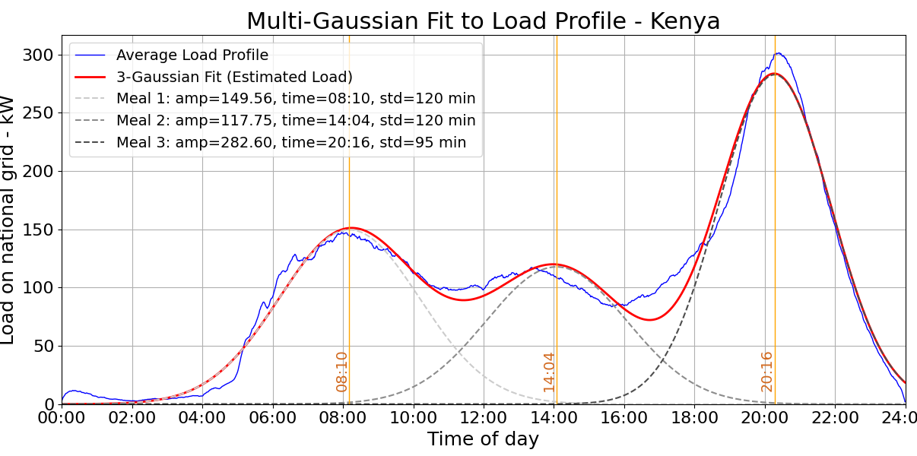
Figure 1 – Fitted gaussian curves for the average load profile seen in Kenya over Jan 2025 – Mar 2025 (BURN data), number of devices = 1469 /day.
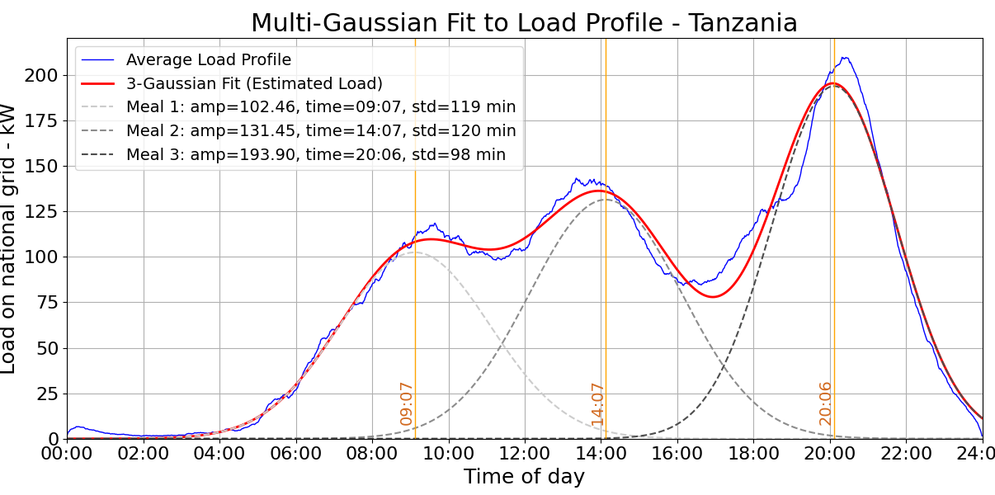
Figure 2 – Fitted gaussian curves for the average load profile seen in Tanzania over Jan 2025 – Mar 2025 (BURN data), number of devices = 1416 /day.
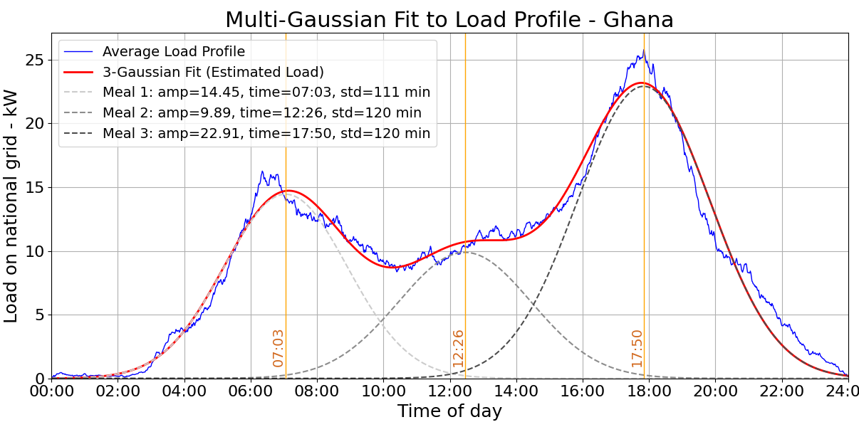
Figure 3 – Fitted gaussian curves for the average load profile seen in Ghana over Jan 2025 – Mar 2025 (BURN data), number of devices = 168 /day.
For each curve representing a mealtime (breakfast, lunch & dinner, shown in grey for each country within the figures) the script outputs the peak amplitude, the standard deviation, and the mean peak power time of day (PPTD). The PPTD, in this instance, represents the mean time of cooking – thinking about how this can be equivalent to a household survey we might imagine this as the mean start time plus half of the mean cooking duration. A PPTD is output for each mealtime and is equivalent to the time at which the gaussian curve representing that mealtime is at its maximum.
In the context of cooking, we expect that the standard deviation represents the standard deviation in the cooking start times, the mean represents the average time that people are cooking at, and the amplitude represents the peak load resulting from the cooking taking place during a mealtime. These equivalents can be seen in Table 1.
As can be seen from Figure 1, Figure 2 and Figure 3, the initial hypothesis is very well supported, and the gaussian curves visually provide a good representation of the real load profiles.
It should be noted that while these gaussian fitted curves are well fitted to the real data, this does not necessarily mean that this representation method will be appropriate for predicting cooking load profiles. While this is an easy conclusion to jump to, these curves are based on an existing knowledge of the target data. We have optimised these curves from the existing load profiles, with the onwards objective being to understand whether aiming to produce these same curves with more limited data could possibly result in appropriate representation of the overall profile.
Specific values which we can extract from this data are shown in Table 1:
Table 1 – Parameters extracted from the gaussian curve fitting process.
Output parameter | Explanation / Cooking context | Units
Meal specific PPTD | Understood to be the mean time of cooking, i.e. mean start time + half mean cooking duration. | Time
Standard deviation | The standard deviation of the meal specific PPTD. | Mins
Load amplitude | The meal-specific peak isolated load, i.e. the amplitude of the normal distribution representing cooking at a given meal. | kW
The results for this IoT data can be seen in Table 2, where meal 1 (M1) is breakfast, meal 2 (M2) is lunch, and meal 3 (M3) is dinner.
Table 2 – Results from gaussian curve fitting.
Sample | Size, N = __ | Meal PPTD |  |  | Standard dev., min |  |  | Load amplitude, kW
Sample | Size, N = __ | M1 | M2 | M1 | M1 | M1 | M3 | M1 | M2 | M3
Kenya | 1470 | 08:10 | 14:04 | 20:16 | 120 | 120 | 95 | 149.6 | 117.8 | 282.6
Tanzania | 1418 | 09:07 | 14:07 | 20:06 | 119 | 120 | 98 | 102.5 | 131.5 | 193.9
Ghana | 168 | 07:03 | 12:26 | 17:50 | 111 | 120 | 120 | 14.5 | 9.9 | 22.9
It may be noted that many of the expected meal distributions shown in Table 2 have a standard deviation of 120 minutes. This is the enforced maximum limit, which means it is likely that a number of these standard deviation values would increase if allowed. In particular, M2 would always ideally accept a higher standard deviation. For the BURN data, there is no “mealtime” label for data reports. It is often the case that the easiest way to achieve a well-fitting curve is to have a very wide central lunch curve, essentially representing all daytime cooking, and nuance the breakfast and dinner peaks with small normal distributions on either side, an example of which can be seen in Figure 4 where the representative curves are generated for the Kenyan load profile with uncapped standard deviation. When working with other common database styles related to cooking, e.g. cooking diaries, data entries are typically labelled by purpose – e.g. breakfast, lunch or dinner. This means that a representation method which is built around these three distinct mealtimes is most appropriate. We would not be able to build a composite curve with a large “cooking” curve alongside small start and end of day peaks from household data, since we would not know what data entries should contribute to the central main ‘cooking’ curve, and what should contribute to the nuanced mealtime peaks. Instead we force the curves to be representative of specific meals – which can be done by limiting their standard deviation. This is why the standard deviation limit has been introduced for the generation algorithm.
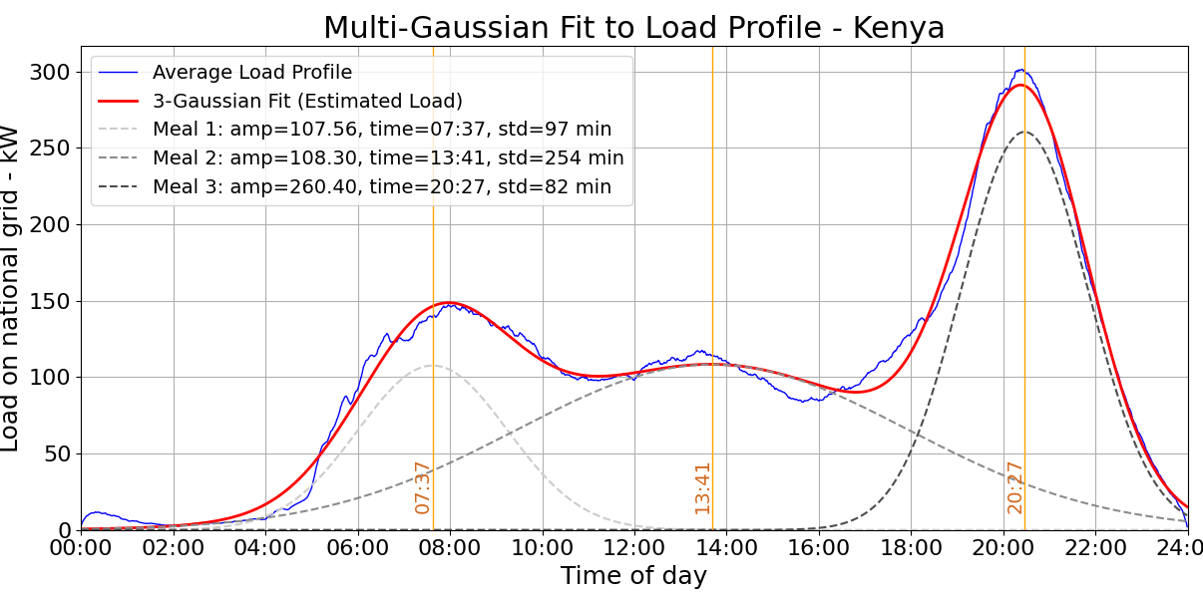
Figure 4 – Fitted gaussian curves with standard deviation uncapped, showcasing the tendency to produce a ‘wide’ lunchtime curve realistically representing ‘general daytime cooking’, rather than lunchtime cooking specifically.
It should be noted that the meal-specific PPTD is not coincident with the highest peak load times seen on the load profile. They are coincident with the peak load of each contributing meal – i.e. the times at which the three contributing gaussians each peak. We can see in Figure 4 that when more than one gaussian is overlaid, the peaks of the summed result do not happen at the same time as the individual peaks of the gaussians. This PPTD is an important parameter used to build the curves but should therefore not be used to estimate the real peak.
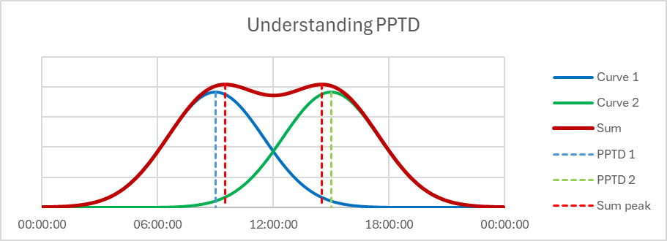
Figure 5 – Showcase of the difference between the time at which the meal-specific load contribution peaks (the PPTD), and the peaks visable on the summed result.

Cooking diaries
High quality IoT data is currently uncommon in the research space. However there are many studies, in particular cooking diaries, performed to investigate cooking habits throughout the developing world. Looking forwards, these studies are far faster and cheaper to perform than the widescale rollout of IoT devices. This means that there is value in understanding whether it is possible to utilise the data gathered from these studies to estimate grid load profiles – if so, this would be a useful tool for energy planners and modellers.
Cooking diaries often contain data on a small number of households (typically 5-25) who each report the cooking activities performed over a short period (typically a few weeks), specifically when it took place, how many people it was for, what was used, what meal it was, what dish was cooked, how much fuel was used, etc. These studies are crucial in understanding current cooking behaviours, how people adapt to modern cooking techniques, and what the impacts of these transitions are.

Mealtime Peak LoaD Factors
When aiming to generate the normal curves to prepare a model in advance of an eCooking transition (prior to any collection of electric cooking data), rather than curve fitting to an existing load profile we need to approach the problem from a different direction. Instead of using the gaussian curve parameters as outputs, we need to find reliable ways of estimating them to generate the gaussian curves. The input variables required to generate the gaussian curves are:
- Mean cooking time
- Standard deviation in cooking time
  - This can be approximated from the standard deviation of start time, assuming that cooking longer / shorter meals is independent of start time
- Peak amplitude of breakfast, lunch and dinner
Cooking times and durations are commonly included in cooking diary studies. Assuming that people will continue to cook on approximately the same schedule after a fuel transition, it is already possible to estimate the mean cooking time and standard deviation in cooking time. Estimating the peak cooking load is more difficult.
Diversification factors are derived from peak observed amplitude. We propose the idea that meal-specific peak load factors can be produced from existing load profiles (for example using the observed load profiles generated by BURN’s IoT data) and used to estimate the appropriate amplitude of the three gaussian curves representing the three main meals. This estimate will be based on the maximum possible load and the load observed within case studies. These meal-specific peak load factors can be calculated as below:
$${PLF}_{meal}=\frac{L_{estimate}}{L_{max}}$$
Where ${PLF}_{meal}$ is the peak load factor for the meal, $L_{estimate}$ is the estimated peak load (in kW) for the meal – the amplitude input for a gaussian curve, examples given in Table 2 – and $L_{max}$ is the maximum possible load given the devices in use within the scenario (i.e. the average kW rating of devices in use during a meal, multiplied by the number of devices in the scenario). This lattermost variable is not calculated by summing the kW capacity of all cooking devices available to households together and averaging per household, since we assume that a household who owns multiple devices will not necessarily use all devices for all meals. Therefore in this case, we calculate the max load based on the average combined kW load of devices typically used for a single meal.
For now, we can use our curve fitted gaussians for the BURN case study to generate some standard mealtime peak load factors. This is based on the peak possible daily load when all active users were using their 2kW device (i.e. $L_{max}$) and the estimated meal-specific estimate of the load (i.e. $L_{estimate}$, the amplitude of the gaussian curves seen in Figure 1, Figure 2, and Figure 3). These results can be seen in Table 3:
Table 3 – Mealtime peak load factors generated from BURN IoT data.
Country | Mealtime peak load factors (from meal-specific load contribution)
Country | Breakfast | Lunch | Dinner
Kenya | 0.0509 | 0.0401 | 0.0962
Tanzania | 0.0362 | 0.0464 | 0.0685
Ghana | 0.0432 | 0.0295 | 0.0682

Note on diversification factors
It should be noted that these mealtime peak load factors cannot be used to calculate diversification factors even though it may seem that the calculation for the highest peak is simply the inverse of the diversification factor equation. These peak load factors are generated from the amplitude of the gaussian approximation of cooking, not the real observed peak load. If we use the real peak load instead of the gaussian amplitude and find the inverse of the mealtime peak load factor using:
$${{PLF}_{meal, peak}}^{-1}=\frac{L_{max}}{L_{peak}}$$
where $L_{peak}$ is the peak observed kW load (not the max amplitude of the gaussian representing the meal), we see the results shown in Table 4:
Table 4 – Meal specific inverse peak load factor
Country | Inverse peak load factor (from observed load)
Country | Breakfast | Lunch | Dinner
Kenya | 19.94 | 25.00 | 9.75
Tanzania | 23.89 | 19.76 | 13.50
Ghana | 20.81 | 26.40 | 12.99
Notably we can see that the inverse peak load factor for the dinnertime meal (at which the highest load resides for all countries) is equal to the diversification factors seen in the previous MECS diversification paper (with the small differences resulting from the adjustment from UTC to EAT, and therefore the required omission of January 1st data, which is missing the first three hours of reports). This highlights the difference between the well-known diversification factor, and our proposed peak load factors – since the load factors are meal-specific, they cannot be immediately identified from the raw load profile as this will not account for the influence of the tails of other mealtime gaussians when identifying the peak contribution of a specific meal. They must instead be identified from gaussian profiles fit to a known load profile, as shown in Figure 4.

Applying Peak Load Factors
Given the peak load factors which we have extracted from the IoT data provided by BURN seen in Table 3, we can use these country-specific factors to estimate the load profile which might be present in Kenya, Tanzania or Ghana based on the maximum possible load from a proposed cooking transition. The normalised profiles generated by each of the country specific peak load factors can be seen alongside the original profiles in Figure 5. We look forward to more data from different parts of the countries, cooking device types, etc. confirming that cooking behaviours can be modelled as consistent throughout a country, or providing the additional nuance required to confidently select parameters used to model scenarios of interest.
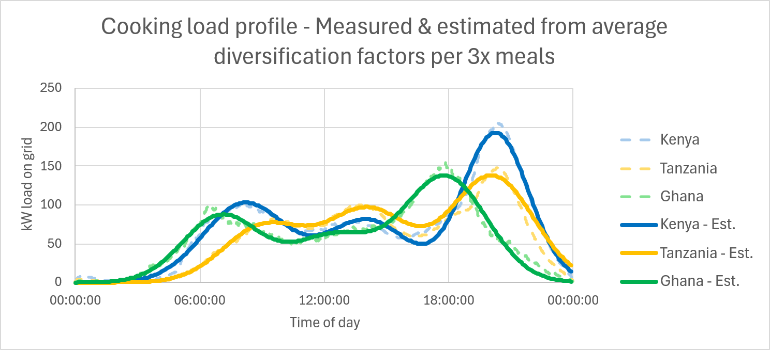
Figure 6 – Real measured loads vs methodology estimate based on country specific mealtime peak load factors.

Utilising Methodology Example
One of the key benefits of using the described methodology to estimate grid load is its minimal input requirement. A cooking diaries example was selected to test the feasibility of the methodology when working with limited data, and no access to IoT reporting.
Detailed below is an example use case of the methodology based on the results from a cooking diary in Kenya.

Data quality
It is important that the data used for analysis and estimation can be filtered into mealtime buckets, as the suggested approach requires the estimation inputs to be built from meal-specific investigation. Errors such as mixed up 12-hour and 24-hour clock times must be rectified before building the input metrics, as leaving such errors in the data will have a very significant impact on the estimation results.

Estimating Maximum Possible Load
The first important metric we need to pull from the data is the meal-specific peak load factors, which, as a reminder, can be calculated from the equation:
$${PLF}_{meal}=\frac{L_{estimate}}{L_{max}}$$
Often in cooking diaries the cooking devices used are consistently reported but (understandably) without specifying their kW rating. This makes the peak possible load ($L_{max}$) more difficult to estimate given its reliance on understanding the maximum simultaneous load. For this cooking diary, we have assigned the below “typical” power ratings to the observed devices seen in Table 5:
Table 5 – Estimated kW ratings of devices included within Kenyan cooking diary.
Device | Assumed kW rating
Rice cooker | 0.7
Microwave | 1.4
Kettle | 3.0
EPC | 1.0
Hotplate | 1.4
Other (mostly deep fryer) | 1.4
These estimates can be used alongside their frequency of occurrence in the household data taken from the cooking diary to estimate the average total kW rating for each meal, and therefore peak possible load (by multiplying this average kW rating of the devices in use by the number of households which report per day).

Minimum inputs
Alongside the reported mealtimes, we are able to calculate the following minimum inputs required for the cooking load estimation methodology from the data reported in the cooking diary in the case study. These values can be seen in Table 6. Note that the meal specific peak load factors are carried forwards from Table 3 to represent the behaviour we have seen from Kenya (where in an ideal world these peak load factors are identified from any available source which best represents the target population). Note that we must use some existing factors to support our estimates here, since the methodology is proposed for use when an investigation to the level required to produce the peak load factors from the target population is not feasible – i.e. all other parameters can be generated from only a baseline household survey.
Table 6 – Input parameters used to estimate the gaussian load profile for the cooking diary, parameters typically generated directly from the cooking diary unless stated otherwise.
Meal | Meal peak power time of day | Standard deviation (hours) | Average kW of device | Peak load factor (from IoT data)
Breakfast | 07:15:32 | 2.258 | 1.36 | 0.0509
Lunch | 12:34:38 | 1.564 | 1.23 | 0.0401
Dinner | 18:41:28 | 1.764 | 1.41 | 0.0962
The amplitude of the peak load for each mealtime is calculated based on the library peak load factor for each meal, using the following equation:
$$L_{estimate}={PLF}_{meal}×L_{max}$$
Where $L_{estimate}$ is the expected observed amplitude (of the meal load profile, contributed by each specific meal), ${PLF}_{meal}$ is the peak load factor for specific meals and $L_{max}$ is the maximum possible load for the meal – i.e. the average kW rating of the devices used during a meal multiplied by the number of households reporting per day.
At this stage it is not of interest to compare the estimated profiles for the cooking diary with the profiles generated from the BURN data, since the peak load factors used to generate the cooking diaries estimation are based on the Kenya peak load factors observed in the BURN data. This means the two are essentially built from the same building blocks, and therefore their matching holds less meaning than might be assumed.
The estimated load profile produced from this approach can be seen below in Figure 4:
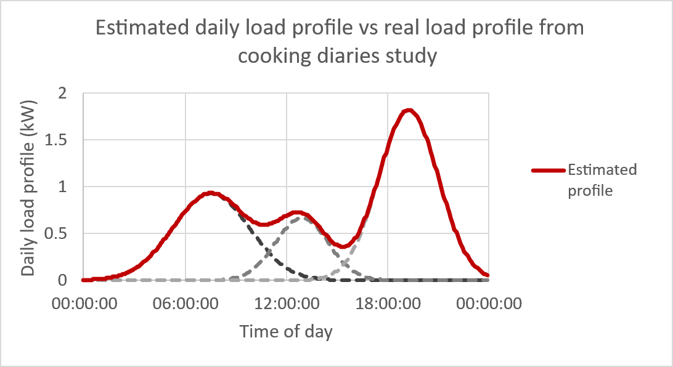
Figure 7 - Estimated load profile (averaging 13.5 households per day) built from cooking times reported within cooking diaries study, and peak load factors pulled from the analysis of IoT BURN data in Kenya (both studies undertaken in Kenya).
Event Specific Reporting
Using a cooking diaries study is really a middle ground between a large, automated data collection approach from which load profiles can be created directly rather than estimated (e.g. the BURN IoT data), and a rapid small study which aims to uncover only the minimum amount of information to estimate the load profile. This is because from the data gathered in the cooking diaries we can extract both the basic data which would have been gathered in a rapid study to trial our estimation methodology, as well as producing a load profile from the reported specific cooking timings and energy consumption.
The cooking diaries study used in this case study can be used to model the load profile of the population using the same approach described in our previous working paper which describes the modelling process used for the BURN IoT data. From this we can generate two load profiles using distinct methods with the intention of comparing the two to validate our proposed methodology.
Firstly, we can create a load profile directly from the reported cooking events. Here, for each cooking event recorded, we spread out the reported energy consumed (measured in kWh) over the reported cooking period to calculate an average power draw over the duration of each cooking event, and then summing the results of all dishes cooked over the course of a day. The resulting load profile seen in Figure 7 has been calculated as the average daily load profiles for all days included in the study period.
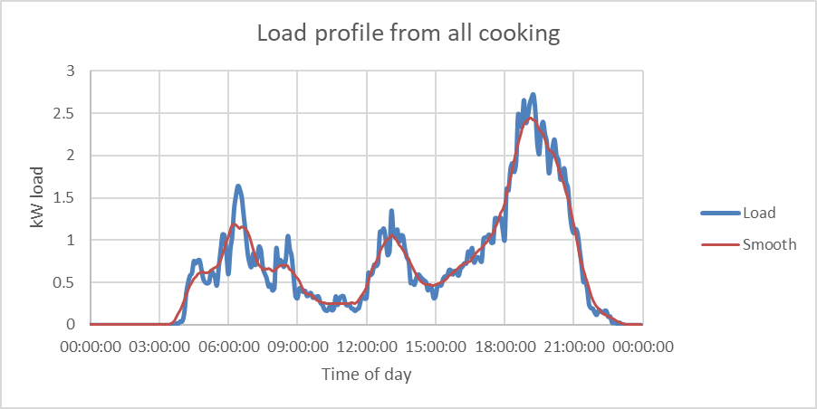
Figure 8 – Estimated load profile from cooking diaries calculated from reported energy consumption and cooking periods (blue: raw profile, red: 1 hr moving average).
Since this household study is limited to only 19 reporting households, we do not see a particularly smooth load profile. This is a common feature of cooking diaries, as they lack the number of participants often available to larger automated collection methods such as IoT. We have therefore applied a moving average to the data to more clearly showcase a typical profile type which might be expected for a larger sample size.
The second approach is to use the estimation method proposed in this working paper. This profile is calculated using the input parameters shown in Table 6. The reported load (see Figure 7) and estimated load (see Figure 6) from the two methods can be seen overlaid below in Figure 9:
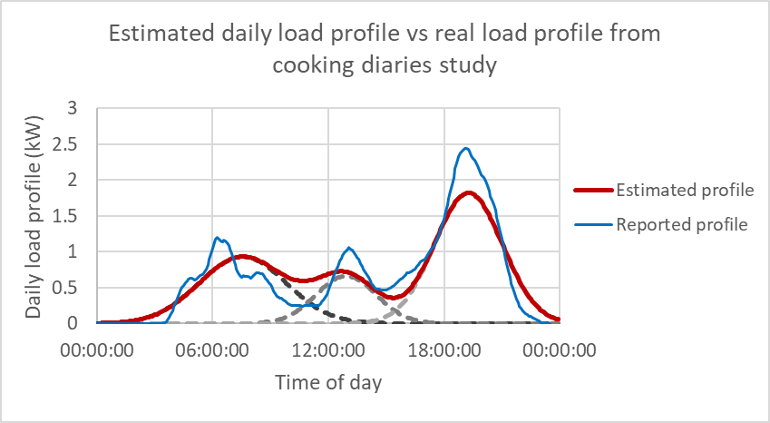
Figure 9 – Estimated load for household cooking diaries study based on the reported energy consumption and cooking period, uses 1-hour rolling average

Reflection on consistency
As can be seen in Figure 9, the estimation approach (shown in red) is very promising in terms of replicating the reported profile. That being said it does slightly underestimate peak consumption at all meal peaks. This may be a result of behavioural differences between the IoT device use in the BURN data, and the population surveyed during the cooking diary (e.g. cooking behaviour, differences in device type impact on load profiles, differences in device kW capacity on load profiles, etc.). Further case studies (on both sides) would be required to investigate and confidently understand these differences.
This first use case example appears promising for the generation of estimated load profiles based on only reported already-present cooking times and an understanding of the devices to be deployed (i.e. their kW capacity), and appropriate mealtime peak load factors.
In particular, it should be noted that in order to generate the load profile seen in Figure 8, a full project implementation and data gathering phase for the eCooking additions must be undertaken. In contrast, the load profile seen in Figure 9 only requires the limited parameter set, including the average time meals are cooked, the standard deviation of those mealtimes, the kW capacity of the device (or devices) targeted for implementation, and a peak load factor selected from a library developed from prior implementation projects. All of these variables can be cheaply identified through an initial surveying process, making the approach especially valuable in generating a realistic load profile during the early stages of such a project.

Limitations
There are various limitations which should be considered when looking to apply the grid load estimation methodology put forwards within this paper.
- The modelled load produces a single profile. We have assumed that this most useful profile is the mean load, however the full process would need to be repeated with appropriate adjustments in order to estimate a 95% confidence interval.
- The proposed methodology does not account for realistic power draw patterns – i.e. when cooking, we expect a period of high intensity draw for a heat-up period, followed by effectively low draw for the remainder of the cooking period as the temperature is maintained. This process has assumed that the power draw is constant throughout. For a large sample size, this is reasonable, however will not reflect real behaviour (specifically noise) for small sample sizes.
- Peak mealtime load factors may vary with many factors, including but not limited to the country applied to, the device type in use, the power rating of the device, the proportion of cooking performed using electricity for the modelled sample, the type of meals cooked, social class of the population, occurrence of holidays/events, household size, season, and any number of cultural cooking differences. The estimation methodology would benefit from more reported data with associated details for these kind of factors to adjust the mealtime peak load factors accordingly.
- The application of this methodology requires the modeller to have access to cooking diary-style data on known cooking times (or to reasonably estimate these values), to understand what power rating of devices they plan on deploying, and to select an appropriate peak load factor based on what is currently a very limited bank of information.
- The peak load factors used much be based on an existing library of load factors. This means that currently, they are based on research utilising a single IoT source, which may lead to unreliable estimates for users of cooking devices substantially different. As research into this area expands, and the understanding of cooking load profiles deepens with more nuanced examples and relationships for different countries, meals, etc., this approach will become increasingly reliable.

Conclusion
This paper has demonstrated that daily cooking load profiles can be effectively approximated using a simple Gaussian representation centred on the three main mealtimes. Validation with a large IoT dataset from Kenya, Tanzania, and Ghana confirms that this summed Gaussian approach can accurately represent real-world load shapes, providing a solid empirical foundation for moving beyond single-number diversification factors towards full, minute-by-minute profiles for modelling the nuanced impacts of eCooking adoption.
A key contribution of this study is to show how such profiles can be generated even in contexts where IoT data is unavailable. By identifying the following minimum required inputs: mean cooking start time for meals, the standard deviation of those start times, power ratings of devices in use, and meal-specific peak load factors (built from an existing in-depth study of a similar population) – it is possible to build reasonably realistic load curves from very modest data sources. Our worked example from Kenya illustrates both the promise and the limitations of this approach: the estimated profiles captured the magnitude and timing of cooking loads with encouraging fidelity for most meals, though the accuracy is reliant on good estimates of the peak amplitude of the contributing load from each meal.
Meal-specific peak load factors further operationalise this methodology. These factors allow the amplitude of each mealtime Gaussian to be scaled appropriately, providing a bridge between the theoretical maximum connected load and the realistic contribution of cooking at breakfast, lunch, and dinner. While the initial values reported here are derived from one dataset and three countries, they provide a starting point for building a wider library that can be tailored to different contexts, appliance mixes, and cultural cooking practices.
For planners, the value of this method lies in its accessibility. Unlike approaches that require dense IoT monitoring or detailed data generated from a cooking diary study, this method can be applied prospectively, before a transition takes place, using only modest survey data and reasonable assumptions about the devices to be deployed. The resulting load profiles can then be overlaid on existing feeder or transformer profiles, enabling assessment of whether new cooking demand will exacerbate or shift local peaks, including the timing of the effect. This is a more nuanced tool for decision-making than reliance on diversification factors alone, since the expected post-implementation load profile can be estimated from the expected continuous load, instead of a single peak load.
At the same time, several limitations must be acknowledged. The current library of peak load factors is small and context-specific; further empirical studies are needed across seasons, regions, and appliance types to validate their robustness. In addition, the model does not yet incorporate behavioural change that may occur during transitions, such as shifts in cooking times or menu choices.
Nonetheless, this first formalisation of a Gaussian-based estimation method represents a significant advance in the practical modelling of eCooking demand. It complements the diversification analysis presented in the earlier MECS working paper by offering a pathway to full profile estimation using widely available inputs. With continued refinement and expansion of the parameter library, this methodology could become a standard component of tools such as TIMeC; in the meantime, the accompanying Load Profile Generator Tool, available via the Tools page of the MECS website, gives utilities, regulators, and planners a transparent and accessible way to apply the approach in energy system planning.

Diversification-Effects-for-Practical-Modelling-of-Cooking-Demand-Working-Paper.pdf

